Mr. TM Whitaker

U22744968

Timothy Whitaker u22744968

COS 221 Practical 1

Timothy Whitaker u22744968

**Task 2**

Assumptions:

We are only taking one phone number per student, and we are assuming that the book has only one title, eg. Using “Harry Potter And The Philosopher’s Stone” and not including “Harry Potter And The Sorcerer’s Stone”. We are also assuming that a book has only one author.

**Task 3**

**Task 4**

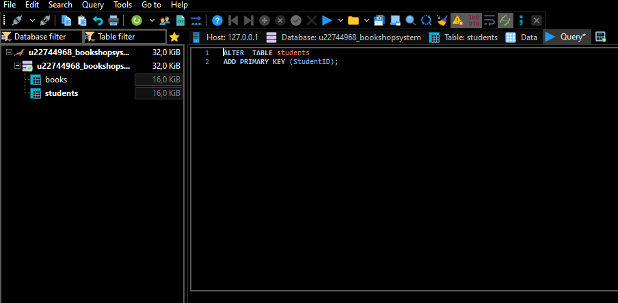

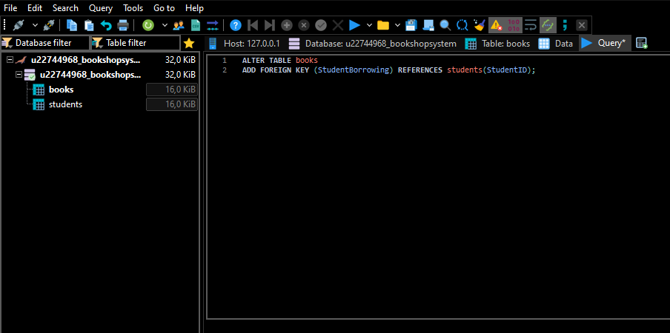

**Task 5**

# **Task 6 + 7**

Please refer to the provided text document.